* To restart the kernel of jupyter notebook: Kernel > Restart & Clear Output
* The command above will reset the state of jupyter notebook IDE. That means all variables are deleted.
* In an if-clause, the default indentation of 4 spaces can be changed, but you have to use whatever number spaces consistently. 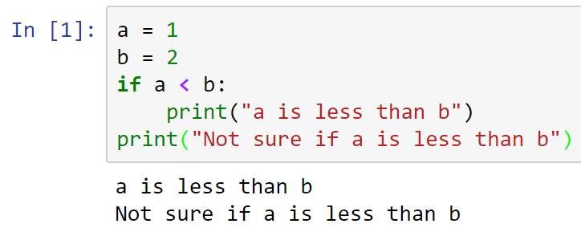
* Change a to 3, and run to see what happens.
* Indentation is used by Python to determine which block (yes or no) a statement belongs.
* 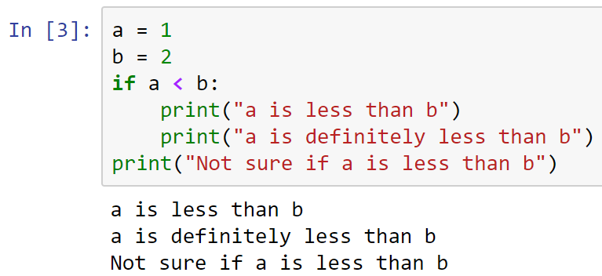
* Python knows which statements belong to the yes-block because of their indentation.
* So, in Python, a colon and the number of space indentation is use to delimit the statements that belong to the true-block of the if-clause. An IndentationError will be thrown if spaces are not consistent.
* 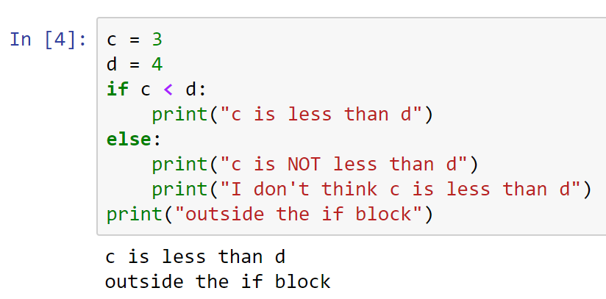
* Change c = 5, and run to see what happens.
* How about multi-if clauses?
* 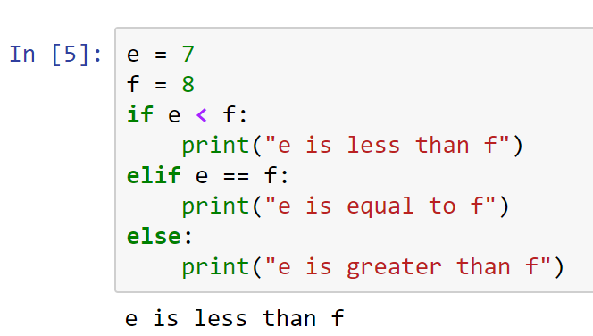
* Change the values of e to test the other two conditions.
* Here is another example for more elif-clause:
* 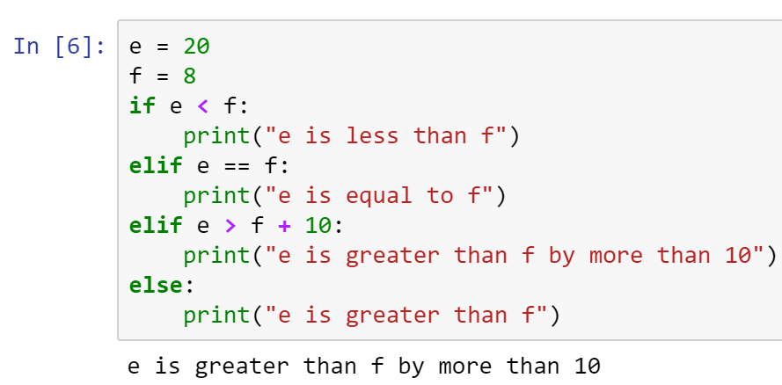
* Here is another way of dealing multiple cases without using the elif-clause.
* 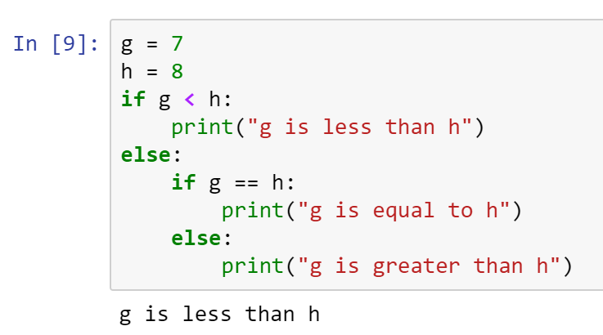
* Change the value of g to 8 and 9, and run to see that the other conditions are okay.

***BMI Calculator*** - determines if a person is overweight based on his/her height and weight.

* 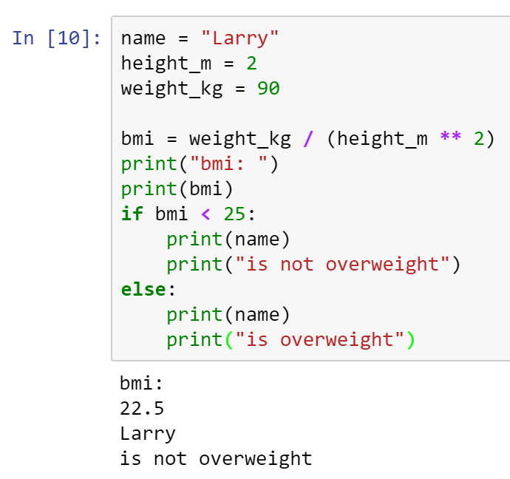
* Change weight to 110, and run to see if Larry is not overweight.
* Research how to print in Python without a newline after the text. In other words, how do you print multiple texts within the same line?
* Place your answer here below:

____________________________________________________________________________

* Copy all your code into a Word doc, place your name on it, and submit in Canvas.